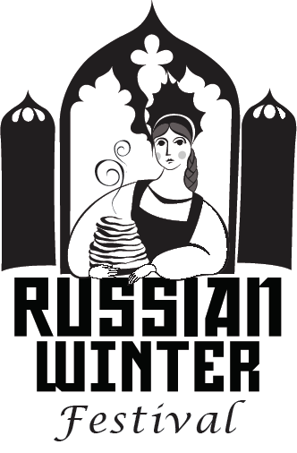
RUSSIAN WINTER FESTIVAL
VENDOR REGISTRATION
www.newrussiacenter.org
Festival Date: Saturday February 29 2020
Location: Polish community Center
225 Washington Ave Ext. Albany NY
11am -5pm

VENDOR NAME _____________________________________________________

TYPE OF CRAFTS ____________________________________________________

_____________________________________________________________________

______________________________________________________________________

_____________________________________________________ _______________

VENDOR CONTACT E-MAIL: _____________________________ PHONE: ______________

VENDOR FEE: $150.00. Make check payable to New Russia Cultural Center.

Items to be sold have to be related to the Eastern European style Art & Crafts. 10x10 booth space will be pre-assigned and includes a table and chair. Vendors must complete registration and submit payment to reserve a booth; registration must be approved. Email/Phone confirmation will be provided once approval. Please provide your own table covering. Also, please donate a door prize item valued at $20 or more. The hall will be open from 10AM-6PM for set up and tear down. Participants may not begin to tear down the stands until 5 pm.

REFUND TERMS: If the Russian Winter Festival 2020 is canceled for any reason whatsoever prior to the day of the event, vendors shall be entitled to a full refund of all paid fees. No other refunds other than those described within the term of this agreement will be allowed.

We will send you a confirmation as soon as we receive your registration form and payment.

Contact: Tanya Deptola, Ph. 518-382-9438, email. tdeptola@gmail.com

VENDOR SIGNATURE:__________________________ Date: _____________

Complete the form and return it with your payment to

New Russia Cultural Center
PO Box 2383
Scotia, NY 12302

