Russian Poetry Recital Contest
Saturday April 12 2025
11am-2pm

Schenectady County Public Library
99 Clinton Street Schenectady, NY

The Contest open to children and adults

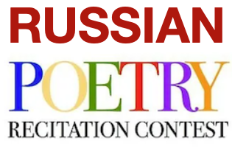 | Register by April 7, 2025
• The Contest open to children and adults

• Three age levels: 3-6, 7-13, 14 and up

• Recitation of a poem in Russia language.

• Two divisions: Native and Non-Native Speakers

The Contest showcases talent in the art of reciting
Russian Poetry,
fostering creativity and linguistic expression.
The aim of the contest to revive children and adults'
interests in reciting poetry in public.

Registration forms are available at

www.newrussiacenter.org/programs/poetry-recital-contest

Event is sponsoring by the New Russia Cultural Center

