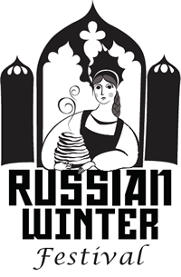 | Tchaikovsky Music Competition 2020  Showcase of Young Performers  Vocal Division  Registration Form | 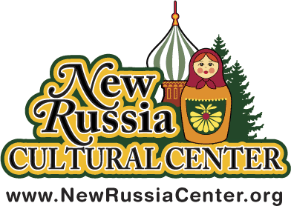

Name
Address
City State Zip
School Level__ Young Adult Level__ Adult Level__
Phone Number Email Address
Accompanist Request Yes ____ No ____
Biography: your musical background, number of years of vocal study, performing highlights (if applicable), career aspirations (musical and/or other). Use back of this form if necessary.

Song Selection, name of composer and length of selection in minutes:

Vocal Instructor’s Name
Phone Email Address
- Please include two copies of the music score for a song you have chosen to sing.
- Contestants must sing in Russian. Translation of the songs must be provided.
- All Contestants will receive feedback on their performances at the Awards Ceremony
- The registration fee of $45. - Send a check payable to the New Russia Cultural Center.
- Winners will be announced on stage at the conclusion of each level of the competition.
- Winners will perform at the All Winners Concert and Awards Ceremony on Saturday, February 15th 2020 at 1:30pm.
- Contestants have a choice to have their own accompanists for the competition or request service of the local accompanists ($25 fee will be collected at the competition.)
Please mark Yes on the form if you would like to request an accompanist and include an additional copy of the music score in your package.

The Vocal Division will take place on Saturday, February 8th 2020 at 1:30pm at
the New Russia Cultural Center, located 1550 Broadway Rensselaer 12144.

Return your Registration Form by February 1, 2020 to
Tchaikovsky Music Competition/New Russia Cultural Center
PO Box 2383 Scotia, NY 12302
www.newrussiacenter.org/winter/festival-events/music-competition/vocal-division

