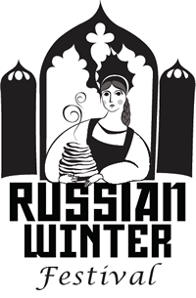 | Tchaikovsky Music Competition 2020  Showcase of Young Performers  Piano Division  Registration Form | 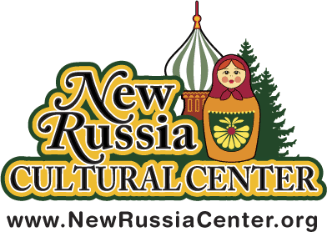

Name
Address
City State Zip
Age Birth Date _Young Level (6-10) _Junior (11-13) _Senior (14-18)

Phone Number Email Address
Years of Piano Study Place of Study
Tell us highlights about yourself in 50 to 75 words:
Suggested topics: how long you have studied an instrument, special awards or recognitions. Your choice: what makes music rewarding for you, or how you envision music being part of your future. (Use back of this form if its necessary)

Music selection, name of composer and length of selection in minutes __ (can’t exceed 5 min):

Piano Instructor’s Name
Phone Email Address
- Please include one copy of the selection you have chosen to play for the competition.
- Pieces of music must be memorized.
- The registration fee of $45 is non-refundable.
- Send a check payable to the New Russia Cultural Center.
- Winners will be announced at the conclusion of each level of the competition on February 8 2020.
- Winners will perform at the All Winners Concert on February 15 2020 at 1:30pm.

Return your Registration Form by February 1, 2020 to
Tchaikovsky Music Competition/New Russia Cultural Center
PO Box 2383 Scotia, NY 12302
www.newrussiacenter.org/winter/festival-events/music-competition/piano-division

PARENTAL PERMISSION: I [circle] (give) (do not give) permission for my child’s picture and name to be released online and in area newspapers.

Signature of Parent or Guardian_____________________________

