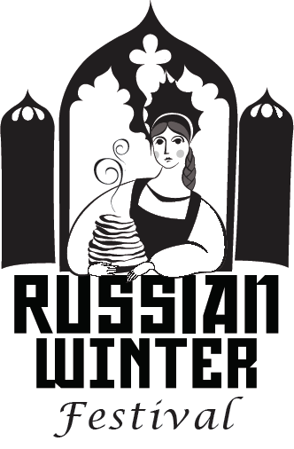
RUSSIAN WINTER FESTIVAL
SPONSORSHIP AGRREMENT
www.newrussiacenter.org
Festival Date: February 29 2020
Location: New Russia Cultural Center
1550 Broadway Rensselaer NY 12144

We are seeking your support for the 12th Annual Russian Winter Festival in the Capital Region of New York State by placing your ad in our Program Booklet. We will place your corporate logo with link to your website on our festival page until the end of 2020. Other sponsorship opportunities are available for the major sponsors.

SPONSOR NAME: _____________________________________________________

SPONSOR CONTACT: E-MAIL _____________________________ PHONE: ______________

AD SIZES:

____ $60.OO – BUSINESS CARD SIZE;

____ $100.00 – QUARTER PAGE;

____ $160.00 – HALF PAGE;

____ $250.00 – FULL PAGE/

Please electronically submit your ad by emailing a "Camera Ready" copy of your ad in PDF or picture format to festival@newrussiacenter.org. Make check payable to New Russia Cultural Center. We will send you a confirmation, as soon as we receive your sponsorship form, ad and payment.

Contact: Tanya Deptola, Ph. 518-382-9438, email. tdeptola@gmail.com

SPONSOR SIGNATURE: __________________________ Date: _____________

Complete the form and return it with your payment to

New Russia Cultural Center
PO Box 2383
Scotia, NY 12302

