New Russia Cultural Center  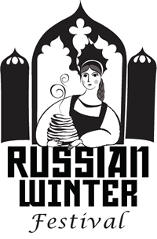 | BEST BRAIDED HAIRDO CONTEST  Registration Form  February 29th 2020  Polish Community Center  Albany, NY
Name Age
Name of Parent/ Guardian (for child entrant)
Address
City State Zip
Phone Number Email Address

Eligibility: The contest is open to all girls and women of all ages.

Entrance Requirement: Parents or guardians, please, read carefully the Best Braided Hairdo Contest rules, including the eligibility requirement and waiver of liability provisions. Complete the document and sign it below.

Contest Rules:
- Sign-in is on Saturday, February 29th 2020, at 2:15pm at the Festival site at the Polish Community Center, located at 225 Washington Ave. Ext. Albany, NY.

- Contest starts promptly at 2:30pm.

- Non-professional hair stylists will do contestants’ braided hairdos on the site.

- Time to make braided hairdo is limited to 20 minutes.

- Hair extensions are not allowed! Ornaments and hair accessories are acceptable; however, be sure the actual hairstyle can be clearly seen.

- The winners will be chosen by judges’ votes at the end of the contest.

- Judging will be based upon neatness, creative approach, and harmony between hairstyle, dress, and appearance.

- Prizes will be awarded to the best three hairdos.

- Photos taken during the contest and video of announcement ceremony will be used for promotional purposes for the Russian Winter Festival.

Registration form can be sent via email to festival@newrussiacenter.org or mailed to: New Russia Cultural Center, PO Box 2383, Scotia, NY 12302.

Registration deadline: February 25, 2020.
For more information call Tatiana Deptola at 518-382-9438.

Your signature indicates that you agree by all rules and that all decisions by the Russian Winter Festival management and judges are final.

_______________________________________________________________________
Contestant’s Signature Date

