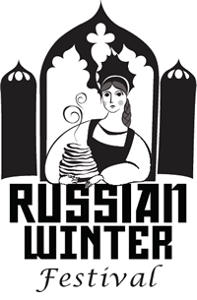 | Best Braided Hairdo Contest  Russian Winter Festival  Registration Form  February 29 2020  New Russia Cultural Center

Eligibility: The contest is open to any non-professional hair stylists including students of hair dressing schools.

Contestant First & Last Name: _________________________________________________________________

Phone Number:_________________________ Email:____________________________________________

Contest Rules:
- Contestants are encouraged to bring their own models, but it’s not required. Participants of the festival - girls and women with long hair - will sign up for being models on site. No mannequins.

- Time to make braided hairdo is limited to 20 minutes.

- Hair extensions are not allowed! Ornaments and hair accessories are acceptable; however, be sure the actual hairstyle can be clearly seen.

- The winners will be chosen by judges’ votes at the end of the contest.

- Judging will be based upon neatness, creative approach, and harmony between hairstyle, dress, and appearance.

- Announcement Ceremony will take place in the Festival main hall at 3:30pm.

- Photos taken during the contest and video of announcement ceremony will be used for promotional purposes for the Russian Winter Festival.

- All contestants will get free admissions to the festival site.

Registration form can be sent by email to info@newrussiacenter.org
Sign-in on Saturday, February 29th 2020, at 2:30pm at the Festival site at the Polish Community Center, located at 225 Washington Ave. Ext. Albany, NY. Contest starts promptly at 3:00pm.

For more information call Tatiana Deptola at 518-382-9438.

Your signature indicates that you agree by all rules and that all decisions by the Russian Winter Festival management and judges are final.

_______________________________________________________________________________________________________
Contestant’s Signature Date

