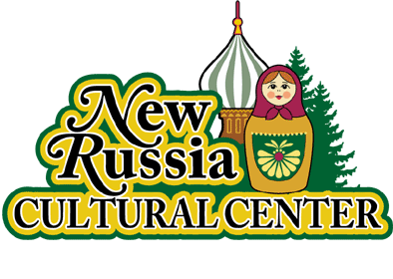 | New Russia Cultural Center  1550 Broadway  Rensselaer NY 12144  www.NewRussiaCenter.org
“CIRCLE OF FRIENDS” MEMBERSHIP

First Name
Last Name
Street address
Phone
Email

Effective dates of ___/___/_____ to ___/___/_____

Membership Due: $30/year
Continuing membership is contingent upon being up-to-date on membership dues.

Members in Good Standing
Members in good standing are entitled to attend general annual and special meetings.
Members are welcome to attend meetings of the Board and to participate in discussions on matters before the Board, but without a vote on matters.
Membership dues and privileges are determined by the Board. Only those persons whose membership is paid for the current year will be members in good standing.
The Board may, at its discretion, terminate the membership of any person at any time by returning that person's current dues.

Membership Activation & Terms of Membership
I understand that annual dues are for a minimum of 12 months and may be cancelled by providing written notice of my intent 30 days prior to the day I wish to have my membership cancelled in accordance with the New Russia Cultural Center policies.

_________________________ _______________________________ ________________
Name (Please Print) | Signature | Date (M/D/Y)

